Factor Analysis

Notes
Output Created |  | 28-JUN-2021 14:40:58
Comments
Input | Data | /Users/coderlax/Desktop/EO Hackathon/Asia/Social Mobility/Z score/Z3.sav
Input | Active Dataset | DataSet11
Input | Filter | <none>
Input | Weight | <none>
Input | Split File | <none>
Input | N of Rows in Working Data File | 86
Missing Value Handling | Definition of Missing | MISSING=EXCLUDE: User-defined missing values are treated as missing.
Missing Value Handling | Cases Used | LISTWISE: Statistics are based on cases with no missing values for any variable used.
Syntax |  | FACTOR  /VARIABLES ZGrocery ZTransit ZResidental  /MISSING LISTWISE  /ANALYSIS ZGrocery ZTransit ZResidental  /PRINT UNIVARIATE INITIAL CORRELATION KMO EXTRACTION ROTATION  /FORMAT SORT  /PLOT EIGEN  /CRITERIA FACTORS(3) ITERATE(25)  /EXTRACTION PC  /CRITERIA ITERATE(25)  /ROTATION VARIMAX  /METHOD=COVARIANCE.
Resources | Processor Time | 00:00:00.17
Resources | Elapsed Time | 00:00:00.00
Resources | Maximum Memory Required | 1984 (1.938K) bytes

Descriptive Statistics
 | Mean | Std. Deviation | Analysis N
ZGrocery | 6.5528602 | .99999998 | 86
ZTransit | 1.8332392 | .99999968 | 86
ZResidental | 2.5551603 | .99999927 | 86

Correlation Matrix
 |  | ZGrocery | ZTransit | ZResidental
Correlation | ZGrocery | 1.000 | -.305 | .569
Correlation | ZTransit | -.305 | 1.000 | -.821
Correlation | ZResidental | .569 | -.821 | 1.000

KMO and Bartlett's Testª
Kaiser-Meyer-Olkin Measure of Sampling Adequacy. |  | .488
Bartlett's Test of Sphericity | Approx. Chi-Square | 136.441
Bartlett's Test of Sphericity | df | 3
Bartlett's Test of Sphericity | Sig. | <.001

a. Based on correlations

Communalities
 | Raw |  | Rescaled
 | Initial | Extraction | Initial | Extraction
ZGrocery | 1.000 | 1.000 | 1.000 | 1.000
ZTransit | 1.000 | 1.000 | 1.000 | 1.000
ZResidental | 1.000 | 1.000 | 1.000 | 1.000

Extraction Method: Principal Component Analysis.

Total Variance Explained
 | Component | Initial Eigenvaluesª |  |  | Extraction Sums of Squared Loadings
 | Component | Total | % of Variance | Cumulative % | Total | % of Variance | Cumulative %
Raw | 1 | 2.156 | 71.882 | 71.882 | 2.156 | 71.882 | 71.882
Raw | 2 | .718 | 23.946 | 95.829 | .718 | 23.946 | 95.829
Raw | 3 | .125 | 4.171 | 100.000 | .125 | 4.171 | 100.000
Rescaled | 1 | 2.156 | 71.882 | 71.882 | 2.156 | 71.882 | 71.882
Rescaled | 2 | .718 | 23.946 | 95.829 | .718 | 23.946 | 95.829
Rescaled | 3 | .125 | 4.171 | 100.000 | .125 | 4.171 | 100.000

Total Variance Explained
 | Component | Rotation Sums of Squared Loadings
 | Component | Total | % of Variance | Cumulative %
Raw | 1 | 1.293 | 43.099 | 43.099
Raw | 2 | 1.085 | 36.182 | 79.281
Raw | 3 | .622 | 20.719 | 100.000
Rescaled | 1 | 1.293 | 43.099 | 43.099
Rescaled | 2 | 1.085 | 36.182 | 79.281
Rescaled | 3 | .622 | 20.719 | 100.000

Extraction Method: Principal Component Analysis.
a. When analyzing a covariance matrix, the initial eigenvalues are the same across the raw and rescaled solution.

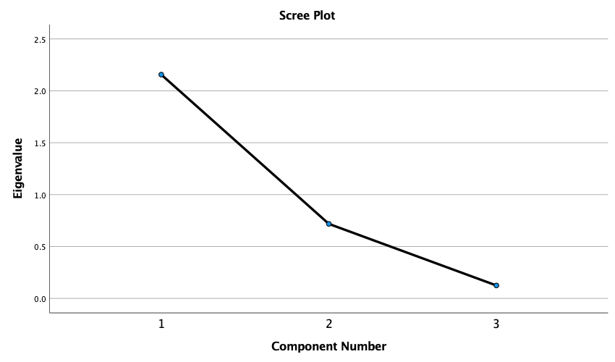

Component Matrixª
 | Raw |  |  | Rescaled
 | Component |  |  | Component
 | 1 | 2 | 3 | 1 | 2 | 3
ZResidental | .958 | -.107 | .264 | .958 | -.107 | .264
ZTransit | -.865 | .454 | .214 | -.865 | .454 | .214
ZGrocery | .700 | .708 | -.097 | .700 | .708 | -.097

Extraction Method: Principal Component Analysis.ª
a. 3 components extracted.

Rotated Component Matrixª
 | Raw |  |  | Rescaled
 | Component |  |  | Component
 | 1 | 2 | 3 | 1 | 2 | 3
ZTransit | .952 | -.123 | -.282 | .952 | -.123 | -.282
ZGrocery | -.138 | .971 | .195 | -.138 | .971 | .195
ZResidental | -.607 | .357 | .710 | -.607 | .357 | .710

Extraction Method: Principal Component Analysis.
Rotation Method: Varimax with Kaiser Normalization.ª
a. Rotation converged in 4 iterations.

Component Transformation Matrix
Component | 1 | 2 | 3
1 | -.696 | .523 | .492
2 | .556 | .826 | -.091
3 | .454 | -.210 | .866

Extraction Method: Principal Component Analysis.
Rotation Method: Varimax with Kaiser Normalization.

